Name: Aspeta Divakar

Trainer Name: Harshee Pitroda

Course Name: Python & Machine Learning

Date:24/05/2022

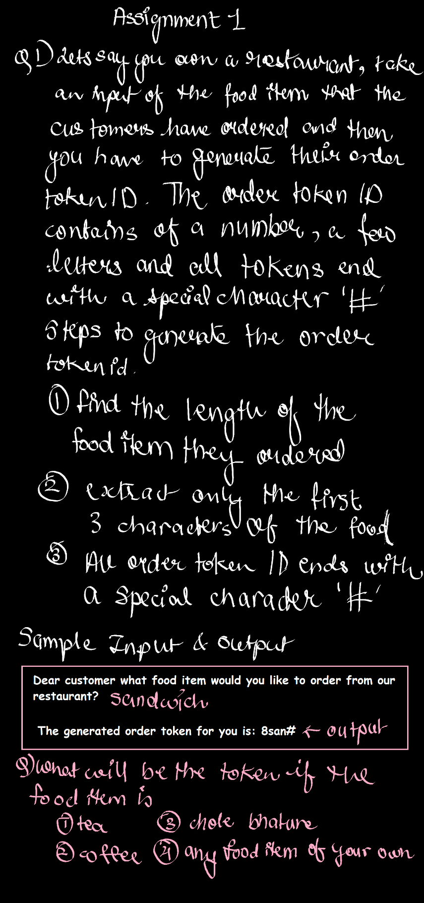

Code1:

1. food='tea'

ln=str(len(food))

a=ln+food[0:3]

print(a,end='#')

1. food='coffee'

ln=str(len(food))

b=ln+food[0:3]

print(b,end='#')

1. food='chole bhature'

ln=str(len(food))

c=ln+food[0:3]

print(c,end='#')

1. food='sugarcane juice'

ln=str(len(food))

d=ln+food[0:3]

print(d,end='#')

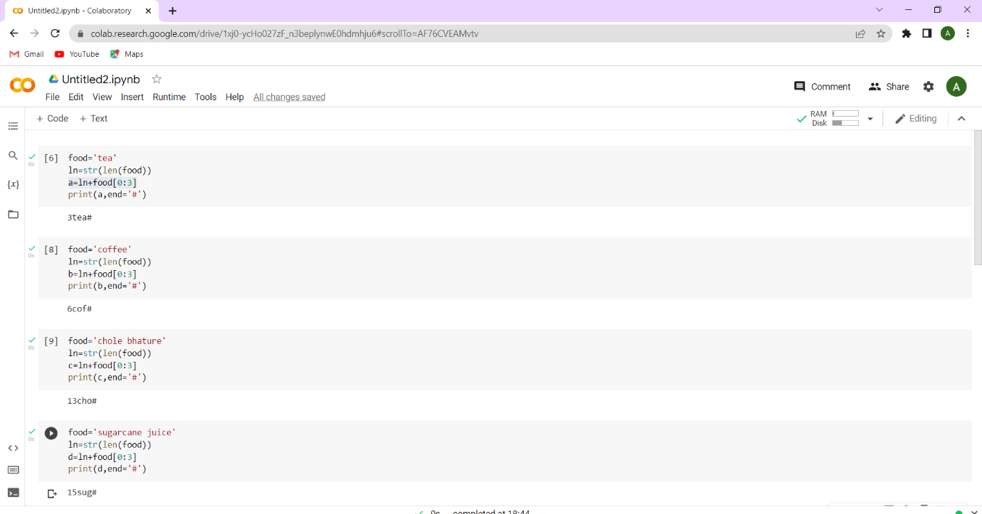

Code2:

food1='tea'

food2='coffee'

food3='chole bhature'

food4='sugarcane juice'

ln1=str(len(food1))

ln2=str(len(food2))

ln3=str(len(food3))

ln4=str(len(food4))

a=ln1+food1[0:3]+'#'

b=ln2+food2[0:3]+'#'

c=ln3+food3[0:3]+'#'

d=ln4+food4[0:3]+'#'

print(a,b,c,d,sep='\n')

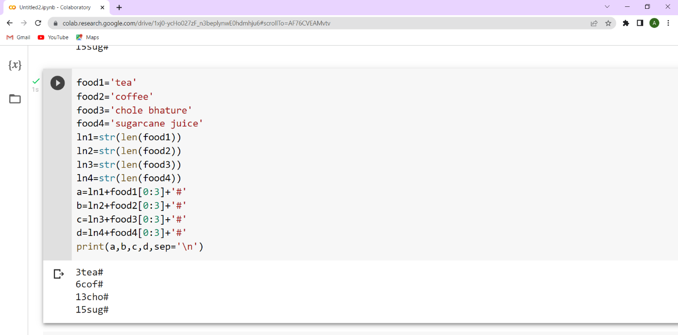

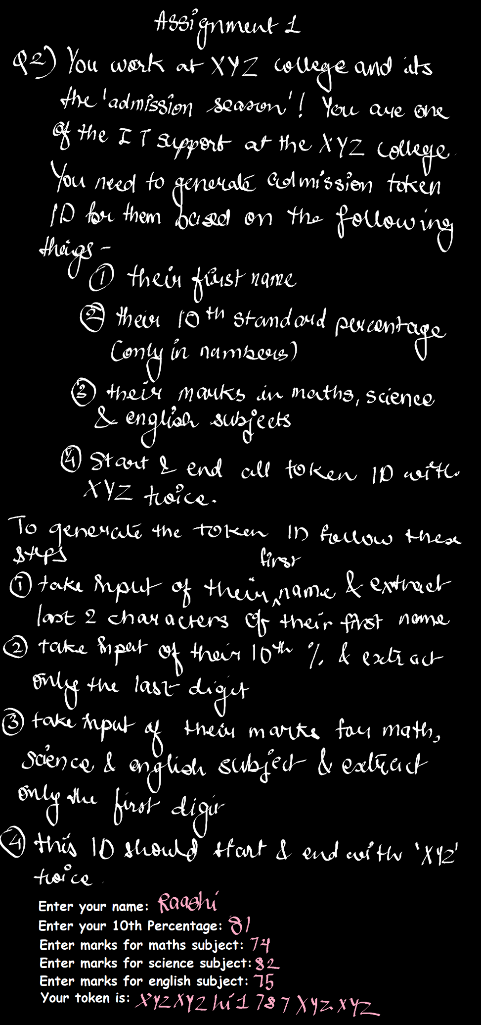

Code:

Name=input("Enter your Name:")

Tenth=input("Enter your 10th percentage:")

Maths=input("Enter marks for maths subject:")

Science=input("Enter marks for science subject:")

English=input("Enter marks for english subject:")

a=(2\*'XYZ')+Name[5:7]+Tenth[1:]+Maths[:1]+Science[:1]+English[:1]

print("Your token is:",a,end=2\*'XYZ')

